Moving Dev and Test Government Systems to the Cloud

### Filipe Atanes, Karolina Kowal, David Felix

#### YWCC 307 - 120

#### Sathish Rajamani

## 

## 

## Introduction

The purpose of this paper/presentation is to present the benefits and potential of using cloud services for Dev and Test Government Systems at the Department of Homeland Security (DHS). Cloud services are rapidly becoming a popular option for organizations due to their scalability, flexibility, and cost-effectiveness. Our report will provide an overview of the different types of cloud services, including Infrastructure as a Service (IaaS), Platform as a Service (PaaS), and Software as a Service (SaaS), and how they can be used to support DHS's workspaces. Additionally, we will provide examples of successful cloud implementations in the government sector and discuss the advantages they have brought to the organizations. By the end of this report, we hope to have presented a compelling case for the adoption of cloud services in DHS's Dev and Test Government Systems. Before delving into the specifics, we will provide a brief overview and definition of each service model and their as-a-service counterparts.

## Infrastructure as a Service

Infrastructure as a Service (IaaS) is a cloud computing model that provides virtualized computing resources over the internet. This means that instead of purchasing and maintaining physical servers and storage devices, the government can rent computing resources from a cloud service provider like Microsoft Azure. IaaS offers many benefits, such as scalability, flexibility, and cost-effectiveness, making it an ideal choice for organizations with varying computing needs. Government agencies can use IaaS to quickly provision and deprovision computing resources as needed, without having to invest in costly hardware upfront. Additionally, IaaS providers offer built-in security measures, such as firewalls and data encryption, which can help government agencies comply with security regulations. By utilizing IaaS, the government can reduce operational costs, improve efficiency, and ensure better availability of resources to meet their evolving IT needs.

## Platform as a Service

Platform as a Service (PaaS) is another cloud computing model that provides a platform for developers to build and deploy applications without having to manage the underlying infrastructure. With PaaS, the government can focus on developing and deploying applications, rather than worrying about the complexities of the infrastructure. PaaS can be used for a wide range of use cases, including web application development, mobile application development, and data analytics. Government agencies can leverage PaaS to quickly develop and deploy applications in a secure, scalable, and cost-effective manner. For example, the Google Workspace platform can be used in work-devices to improve the efficiency of the workflow and restrict the machines to be used more productively. By utilizing PaaS, the government can reduce the time and resources required to develop and deploy applications, while also ensuring that they are built with the latest security measures and best practices. This can result in improved operational efficiency, reduced costs, and better application performance.

## Software as a Service

Software as a Service (SaaS) is a cloud computing model that provides access to software applications over the internet. With SaaS, the government can use software applications on a subscription basis, without having to purchase or maintain the underlying infrastructure or software. SaaS can be used for a wide range of use cases, such as email, document management, customer relationship management (CRM), and enterprise resource planning (ERP). For example, Microsoft Office 365 can be used by the government for tasks such as data sheets, reports, planning, and communication, all in a secure and scalable cloud environment. By utilizing SaaS, the government can reduce the costs associated with purchasing and maintaining software, while also ensuring that they are using the latest versions of the software with the most up-to-date security measures. This can lead to improved operational efficiency, better collaboration, and reduced IT costs for the government.

Benefits of Using Cloud Services

Cloud services offer several benefits over traditional IT infrastructure for government cloud implementation. Firstly, cloud services allow for scalability in terms of storage, processing power, and other computing resources. This enables governments to quickly scale up or down their IT infrastructure as per their requirements, reducing the need for capital expenditures. Secondly, cloud services eliminate the need for governments to invest in hardware, software, and maintenance costs, as all these are managed by the cloud service provider. This results in cost savings and reduces the burden on IT departments. Thirdly, cloud service providers offer a high level of redundancy and disaster recovery capabilities, ensuring that data is safe and available at all times. This provides governments with the confidence that their critical data and applications are always available, without the need for costly backup and recovery solutions. Fourthly, cloud providers offer a high level of security and compliance with government regulations, reducing the risk of data breaches and cyber attacks. This is especially important for government agencies that deal with sensitive information. Lastly, cloud services enable seamless collaboration and communication across different departments and agencies, making it easier to share information and resources.

Cloud services can eliminate the extra cost that the government spends on IT infrastructure. According to Vivek Kunda, a former U.S. Chief Information Officer, he states, “An estimated $20 billion of the Federal Government’s $80 billion in IT spending is a potential target for migration to cloud computing solutions (Appendix 1)” (Vivek Kundra, Office of Management and Budget, 2011). 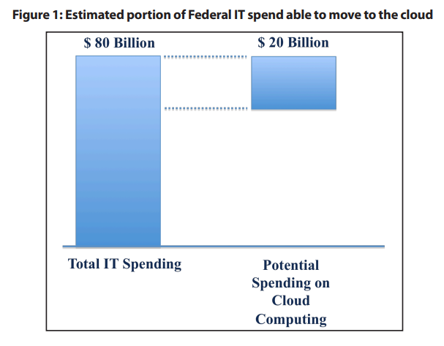

The government has the potential to decrease their expenditures by moving over all of their services to the cloud. The government is planning to spend about $20 billion of their $80 billion that they spend on IT infrastructure to be spent on cloud computing, which is a lot cheaper than what they spend on IT infrastructure. In order for government agencies to provide better IT for less money, they adopted the use of cloud computing services. Since most cloud providers already provide shared resources such as networks, servers, and data storage, this allows government agencies to save money. A total of $291 million dollars has been reported as money saved by transitioning to cloud computing. However, not all government agencies have tracked their spending and savings on cloud computing services. Some examples of how government agencies have moved their services to cloud computing include:

The Department of Homeland Security migrated its information sharing network to the cloud in 2017—ensuring a continuously available network for law enforcement and emergency response during major sporting events and natural disasters. The National Oceanic and Atmospheric Administration deployed public weather websites to the cloud in 2017 to provide timely access to weather data during hurricanes and other extreme weather events. Treasury migrated its system for tracking paper, ink, and other supplies for printing currency and securities to the cloud in 2012, improving its ability to determine how much currency to produce. (Office, U. S. G. A.)

It is extremely crucial that the government takes a risk-based approach to securing its services, data, and cloud environments. The government should transition to a multi-layer defense strategy that is also known as defense-in-depth. A lot of the IT infrastructure already implemented does not have the level of security that cloud computing does. If a device is lost or infected with a virus, then the information on that device is already either lost or at risk of getting stolen by unauthorized parties. However, cloud computing prevents this from happening because the information is saved on there rather than the device.

Cloud services serve a purpose in disaster recovery, and can recover lost information in an easier fashion. Information saved to the cloud can be easily accessed and recovered after a disaster. The same cannot be said if it were only backed up in IT infrastructure which would also take billions of dollars to replace and have it running again. Reducing the amount of IT infrastructure allows the government to spend less money on servers, hardware, and the costs associated to maintain them. Since the cloud provider automatically provides constant maintenance, back ups, and updates, the government would be saving money rather than if they only relied on IT infrastructure.

Cloud services provide the ability for government employees to collaborate simultaneously. Multiple employees can work on the same document at the same time, regardless of where they are. This makes the file sharing process easier and more efficient than before. Managers and employees can also access documents remotely if they are working from home. They can still collaboratively work on projects and access documents remotely. Cloud services are more environmentally friendly since the servers that the cloud providers use are more efficient. Less servers are required and are able to hold the same storage and processing power. Here are some more benefits of moving all governmental services to the cloud (Vivek Kundra, Office of Management and Budget, 2011):

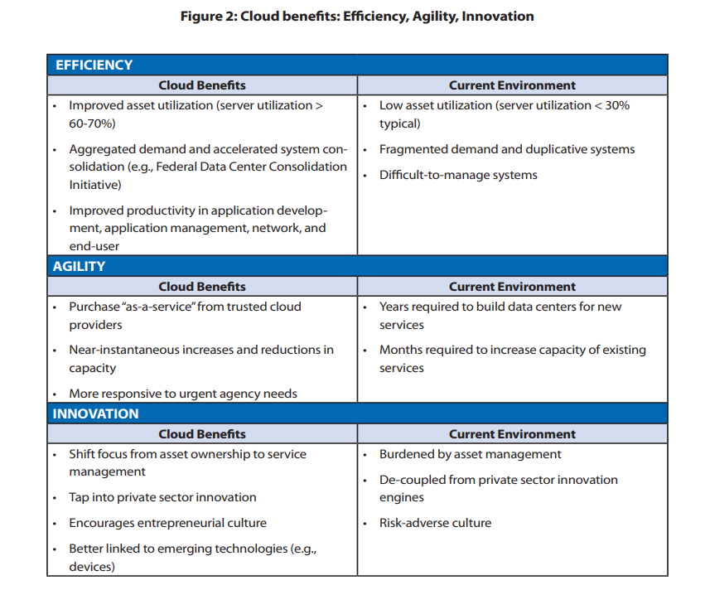

Specific Cloud Services that Pertain to the Government

There are several cloud services that can be used for government cloud implementation, each with its advantages. Firstly, Infrastructure as a Service (IaaS) allows governments to rent computing infrastructure from cloud service providers. This provides governments with the flexibility to scale their IT infrastructure up or down quickly and easily, without the need for significant capital investment. Secondly, Platform as a Service (PaaS) provides a platform for developers to build, test, and deploy applications without worrying about underlying infrastructure. This permits governments to accelerate application development and deployment, reducing the time to market. Thirdly, Software as a Service (SaaS) provides access to software applications hosted on the cloud. This eliminates the need for governments to purchase, install, and maintain software, reducing the cost and complexity of IT infrastructure. Furthermore, cloud storage services provide scalable, secure, and cost-effective storage solutions for government data. This allows governments to store and manage large volumes of data without investing in costly hardware or maintenance. Lastly, cloud security services provide advanced security and compliance capabilities for government cloud implementations. This includes threat detection, vulnerability scanning, and regulatory compliance management. By leveraging these cloud services, governments can streamline their IT operations, improve their security, and deliver better services to their clients.

Three examples of cloud services the government can implement for IasS, PaaS, and SaaS, are Microsoft Azure, Google Workspace, and Microsoft Office 365, respectively. Microsoft Azure enables governments to rent computing infrastructure from the cloud provider. Azure provides computing resources such as virtual machines, storage, and networking capabilities. Governments can easily deploy and manage their IT infrastructure by scaling resources up or down as required. Azure is flexible by allowing governments to customize their infrastructure based on their specific needs. Azure provides security and compliance features, enabling governments to meet regulatory requirements and protect sensitive data.

Google Workspace provides productivity and collaboration tools to governments. With Google Workspace, governments can develop, test, and deploy custom applications, without worrying about underlying infrastructure. Google Workspace contains Google Docs, Sheets, and Slides, which enable collaboration and document sharing. Google Workspace also provides developer tools such as Google App Engine, which allows developers to build and deploy custom applications easily. It also provides advanced threat detection, data loss prevention, and access controls.

Microsoft Office 365 includes applications such as Word, Excel, PowerPoint, and Outlook, which allows governments to create, edit, and share documents, spreadsheets, presentations, and emails. Office 365 also includes collaboration tools such as Microsoft Teams, which enable communication across different departments and agencies. Additionally, governments can access their applications and data from any device at any location which promotes remote work and flexible work arrangements. Office 365 provides data encryption, advanced threat protection, and access controls.

Conclusion

Government agencies should move over their services to the cloud since it will increase overall efficiency, security, and flexibility, reduce overhead costs, and will allow the government to increase and/or decrease IT infrastructure as needed. In case of a disaster, everything will already be backed up in the cloud, so there will not be an increased pressure on the IT department to get things running again. The cloud offers security and reduces the possibility of security breaches since data is saved on there and not on any particular device that can be susceptible to cyber attacks. Cloud computing is the technology of the future that will help deliver faster service to the public, and will increase the rate at which the governmental services run on the private cloud.

# 

# 

# 

# 

# 

# References

Amazon Web Services. (n.d.). AWS for Government. Retrieved from https://aws.amazon.com/federal/?wwps-cards.sort-by=item.additionalFields.sortDate&wwps-cards.sort-order=desc

Built In. (n.d.). 7 Cloud Computing Examples That Will Help You Understand the Technology Better. Retrieved from https://builtin.com/cloud-computing/cloud-computing-examples

cloud.gov. (n.d.). What is cloud.gov? Retrieved from https://cloud.gov/

DesignRush. (n.d.). Types of Cloud Services. Retrieved from https://www.designrush.com/agency/cybersecurity/trends/types-of-cloud-services

Fisher, D. (2021, January 6). The top cloud providers for government. ZDNet. Retrieved from https://www.zdnet.com/article/the-top-cloud-providers-for-government/

Government Accountability Office. (2019). Information Technology: Agencies Need to Develop and Implement Guidelines for Procurement and Management of Cloud Services. Retrieved from https://www.gao.gov/assets/gao-19-58.pdf

GovLoop. (n.d.). Security Procurement Workforce: Cloud Computing. Retrieved from https://go.govloop.com/rs/231-DWB-776/images/Security-Procurement-Workforce.pdf

Kepes, B. (2012, August 31). Homeland Security Plans 12 Cloud Services. InformationWeek. Retrieved from https://www.informationweek.com/cloud/homeland-security-plans-12-cloud-services/d/d-id/1105939

Microsoft. (n.d.). What are Private, Public, and Hybrid Clouds? Retrieved from https://azure.microsoft.com/en-us/resources/cloud-computing-dictionary/what-are-private-public-hybrid-clouds/#faq

Office of Management and Budget. (2011). Federal Cloud Computing Strategy. Retrieved from https://obamawhitehouse.archives.gov/sites/default/files/omb/assets/egov_docs/federal-cloud-computing-strategy.pdf

Office, U. S. G. A. (2023, March 9). *Is the cloud saving the government money?* U.S. GAO. Retrieved April 27, 2023, from https://www.gao.gov/blog/2019/06/27/is-the-cloud-saving-the-government-money#:~:text=To%20deliver%20better%20IT%20services%20for%20less%20money%2C,at%20a%20lower%20cost%20than%20individual%20agencies%20can.

Pandadoc. (n.d.). How to Write a Technical Proposal [Blog post]. Retrieved from https://www.pandadoc.com/blog/how-to-write-a-technical-proposal/

The White House. (2019). Cloud Smart Strategy. Retrieved from https://www.whitehouse.gov/wp-content/uploads/2019/06/Cloud-Strategy.pdf

U.S. Department of the Interior. (n.d.). Cloud Strategy. Retrieved from https://www.doi.gov/cloud/strategy

U.S. Department of the Treasury. (2018). The Treasury Cloud Report. Retrieved from https://home.treasury.gov/system/files/136/Treasury-Cloud-Report.pdf

Zhang, Q., Cheng, L., & Boutaba, R. (2010). Cloud Computing: State-of-the-Art and Research Challenges. Journal of Internet Services and Applications, 1(1), 7-18. doi:10.1007/s13174-010-0007-6